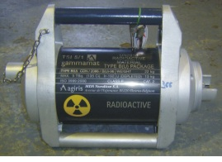 | Ir-192  Date : 13 February 2001  Serial Number : T51  Activity : 135 Ci  Manufacturer : GammaTec NDT Supplies SOC Ltd.
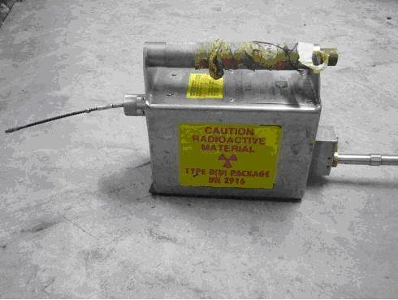 | Ir-192  Date : 1 March 1989  Serial Number : P72  Activity : 120 Ci (4440 GBq)  Manufacturer : Industrial Nuclear Co.,INC
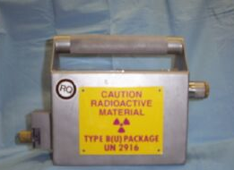 | Ir-192  Date : 7 June 1992  Serial Number : PS-356  Activity : 100 Ci  Manufacturer : Kodiak Quality Control Ltd.
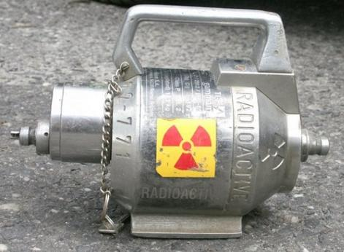 | Ir-192  Date : 5 August 1989  Serial Number : 4771  Activity : 90 MBq  Manufacturer : Sentinel
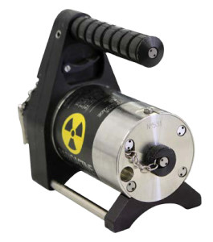 | Ir-192  Date : 1 April 2008  Serial Number :  Activity : 120 Ci  Manufacturer : PACIFIC-TEC Scientific Pte Ltd.
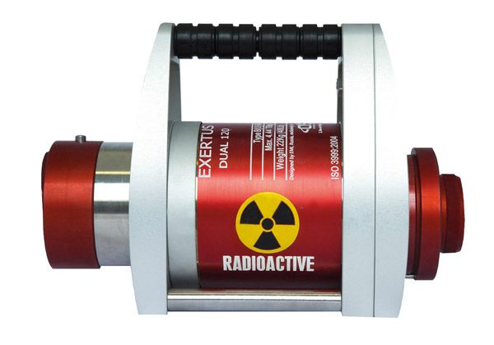 | Ir-192  Date : 1 December 2010  Serial Number : 5034  Activity : 12 TBq  Manufacturer : oserix s.a.
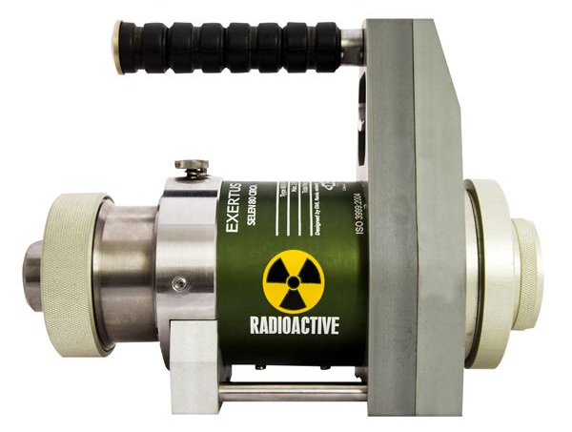 | Se-75  Date : 1 November 2011  Serial Number : BR 9328  Activity : 12 TBq  Manufacturer : oserix s.a.
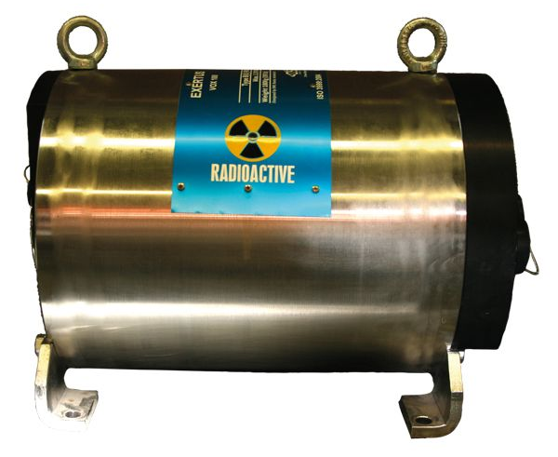 | Co-60  Date : 6 August 1984  Serial Number : 6235  Activity : 256 MBq  Manufacturer : oserix s.a.

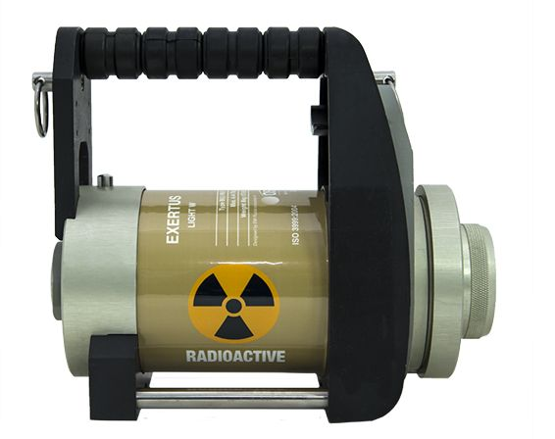 | Se-75  Date : 10 January 2012  Serial Number : 6103  Activity : 12 TBq  Manufacturer : oserix s.a.
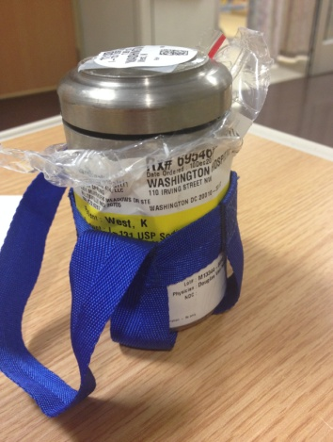 | I-131  Date : 10 Dec 2011  Serial Number : 695464  Activity : 5 MCi  Manufacturer : American Pharmacists Association
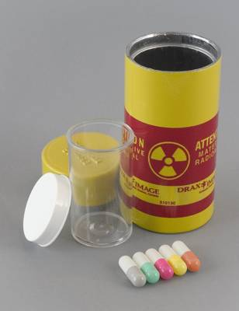 | I-131  Date : 18 July 2015  Serial Number : 20150718-3  Activity : Each capsule contains 3.7 MBq (100 µCi) at time of calibration  Manufacturer : Jubilant DraxImage Inc.
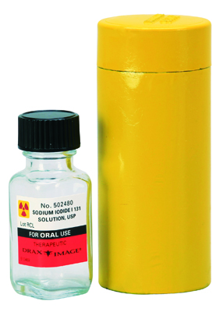 | I-131  Date : 20 August 2009  Serial Number : 502480  Activity : 111 MBq (3 mCi)  Manufacturer : Jubilant DraxImage Inc.
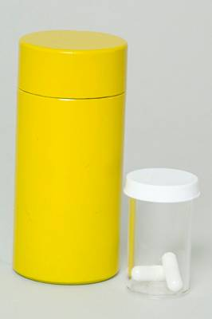 | I-131  Date : 21 February 2010  Serial Number : 6738  Activity : the available minimum activity is 111 MBq (3 mCi) per capsule and the maximum activity is 7400 MBq (200 mCi) per capsule.  Manufacturer : Jubilant DraxImage Inc.
I-131
Date : 7 November 2012
Serial Number : 502480
Activity : the available minimum activity is 111 MBq (3 mCi) per vial and the maximum activity is 7400 MBq (200 mCi) per vial
Manufacturer : Jubilant DraxImage Inc.

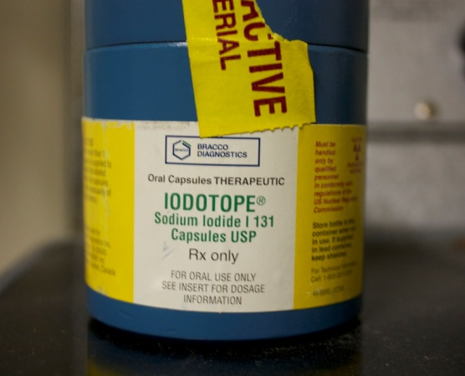 | I-131  Date : 15 March 2001  Serial Number : Lot.No. 4290  Activity : 5 TBq  Manufacturer : Bracco Diagnostics

Yellowcake
Date : 10 May 1999
Serial Number : 5689
Activity : 250 g (3 mCi)
Manufacturer : Uranium Energy Corp

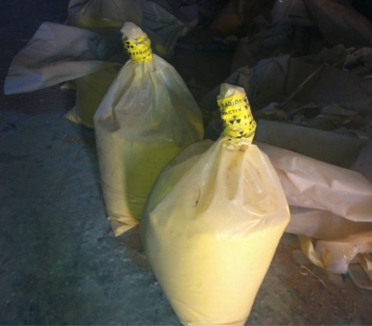 | Yellowcake  Date : 13 October 1985  Serial Number : Batch 2000-10-07-34  Activity : 5 Kg (120 mCi)  Manufacturer : Wyoming Mining Association
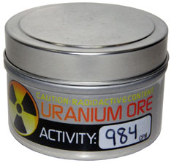 | Uranium Ore  Date : 9 July 1999  Serial Number : UO-3091  Activity : 984 cpm  Manufacturer : Images SI Inc.
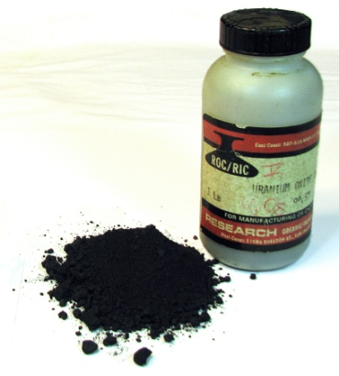 | Uranium Oxide (U₃O₈)  Date : 8 September 1984  Serial Number : 1124  Activity : 1 Kg  Manufacturer : Research organic
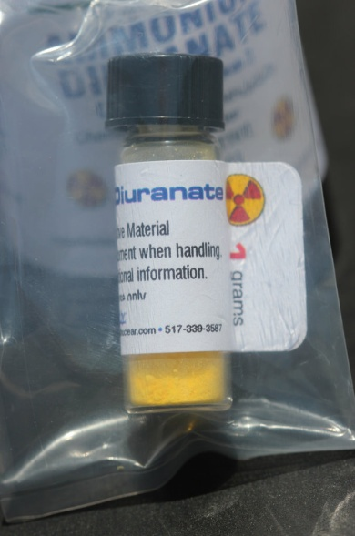 | Yellowcake  Date : 17 October 2006  Serial Number : 2684  Activity : 1 g (2 mCi)  Manufacturer : Borated Manufacturer
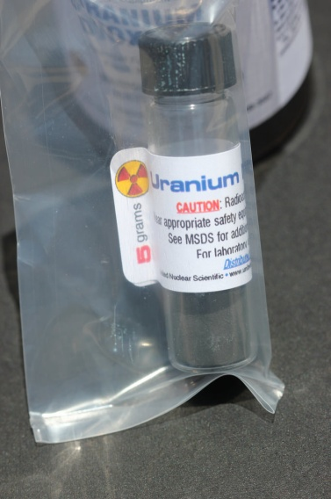 | Uranium Dioxide  Date : 6 June 2005  Serial Number : 892  Activity : 1 g (2mCi)  Manufacturer : Borated Manufacturer
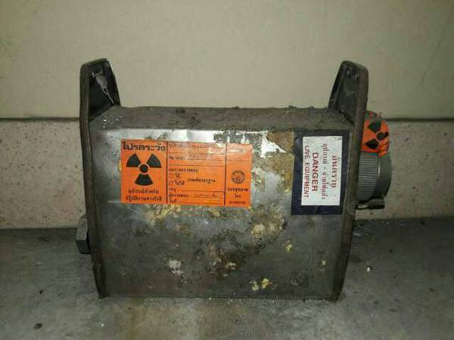 | Ir-192  Date : 5 May 1995  Serial Number : C831  Activity : 107 TBq  Manufacturer : Nordian International Inc.
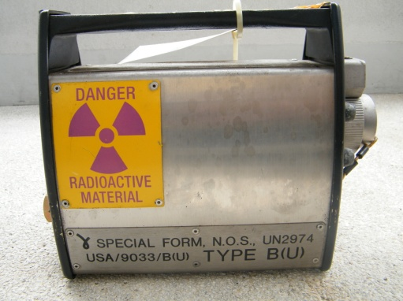 | Ir-192  Date : 6 Sep. 2007  Serial Number : P38  Activity : 105 Ci  Manufacturer : Source Radiographics (Aust.) Pty Ltd

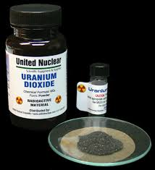 | Uranium dioxide (UO₂)  Date : 16 April 2010  Serial Number : Lot 3450834  Activity : 0.1 μCi  Manufacturer : United Nuclear
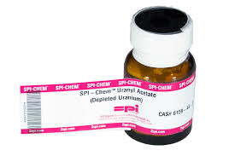 | Uranyl Acetate  Depleted Uranium  Date : 10 October 2014  Serial Number : 6158  Activity : 25 gram  Manufacturer : SPI-CHEM
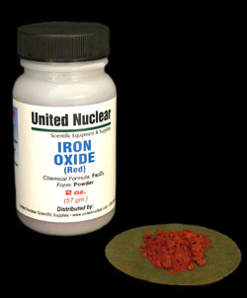 | Iron Oxide  Date : 18 July 1996  Serial Number : 942  Activity : 2 o.z.  Manufacturer : United Nuclear
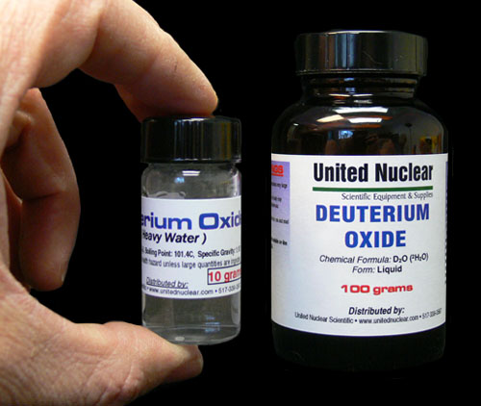 | Deuterium Oxide  Date : 24 January 2014  Serial Number : 13067  Activity : 100 grams  Manufacturer : United Nuclear

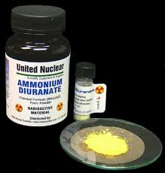 | Ammonium Diuranate  Date : 23 July 2013  Serial Number : 17089  Activity : 100 gram  Manufacturer : United Nuclear
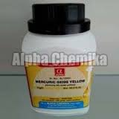 | Mercuric Oxide Yellow  Date : 12 February 2013  Serial Number : 3502  Activity : 250 gram  Manufacturer : Kodiak Quality Control Ltd.
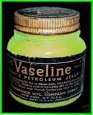 | Vaseline  Date : November 1936  Serial Number : -  Activity : 3 μCi  Manufacturer : Company
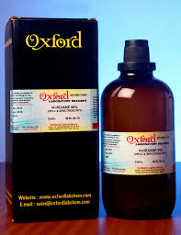 | Oxford  Date : 27 February 1989  Serial Number : Lot.No. 356/1998  Activity : 56 mCi  Manufacturer : Oxford

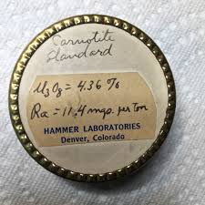 | Triuranium Octoxide (U₃O₈)  Date : 14 May 1956  Serial Number :  Activity : 4.36%  Manufacturer : Hammer Laboratories
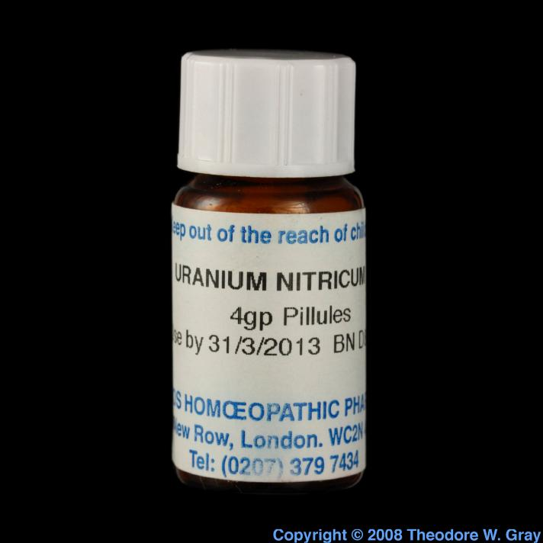 | Uranium Nitricum  Date : 31/3/2013  Serial Number : 3529  Activity : 4gp Pillules  Manufacturer : Homoeopathic Meteria Medica
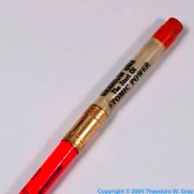 | Uranium Ore  The Start of Atomic Power  Date : 29 October,2004  Serial Number : 421  Purity : < 10%  Manufacturer : Blake Ferris  Contributor: Theodore Gray
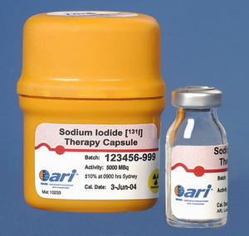 | Sodium Iodide  Therapy Capsule  Date : 3-Jan-04  Serial Number : 123456-999  Activity : 5,000 MBq  Manufacturer : ari

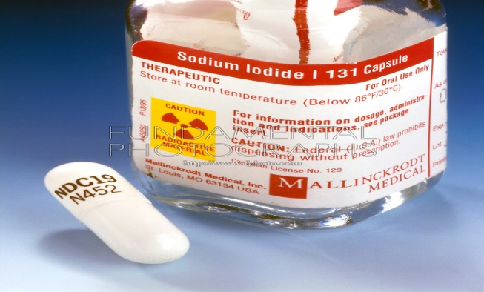 | Sodium Iodide I131  Date : 5 April 2015  Serial Number : N452  Activity : 500 μCi  Manufacturer : MALLINCKRODT MEDICAL
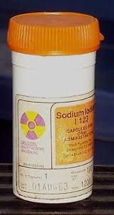 | Sodium Iodide  I-123  Date : 1-AUG 03  Serial Number : 50246100000  Activity : 18.5 MBq (500 μCi)  Manufacturer : Medi-Physic, Inc.
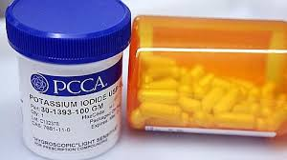 | Potassium Iodide  Date : 29 October 2011  Serial Number : 30-1393-100GM  Activity : 50 pellets  Manufacturer : PCCA

